CSE430 Lab01
Name: Subhi Bhuiyan
ID: 17201116

Task 01
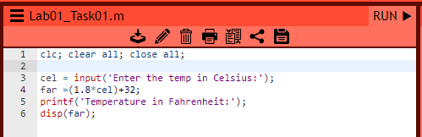
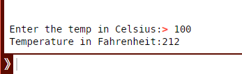

Task 02
